How to Reverse Engineer your Competitor’s Email Marketing Strategy
Updated: June 1st, 2020
Execution Time: ~2h

Goal: To reverse engineer your competitor’s email marketing strategy.

Ideal Outcome: You have a standardized audit that shows you what your competitor is doing (including the exact emails they send).

Prerequisites or requirements: None.

Why this is important: Your competitor (especially if he has been at the game for longer than you) might have optimized their email marketing strategy throughout time, and he might have strategies in place that you might want to apply yourself.

Where this is done: On your competitor’s website, and/or Mailcharts.

When this is done: As soon as possible, ideally when you start your business. After that, you should be monitoring your competitor’s moves at least every 2 months.

Who does this: The person responsible for email marketing.

Environment setup

- This SOP offers 2 different procedures. In the end, which method you choose it boils down to your budget, select the method you’d rather use first and make sure you have the required accounts:

  - Using Mailcharts (Paid)
This is the preferred solution. It will get you access to the emails your competitors have been putting out (so long as your competitors are already being tracked by Mailcharts) and will also give you access to email reports that you would have to create manually otherwise.
    - If you are using Mailcharts, make sure you have an account already.
    - If your company doesn’t have a Mailcharts account you can sign up here. To follow this SOP, you’ll need at least the ‘Starter’ plan.

  - Using a simple inbox (Free)
    - If you are using this procedure create a separate inbox just for this purpose.

(Option 1 - Mailcharts) Add a competitor to Mailcharts

- On Mailcharts, search for the brand you’d like to reverse engineer:
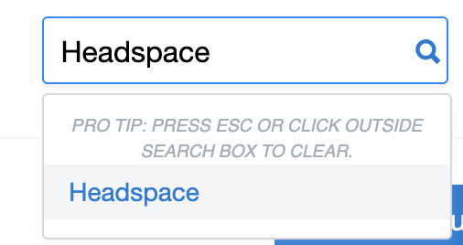
- Click “Emails” → “Track”
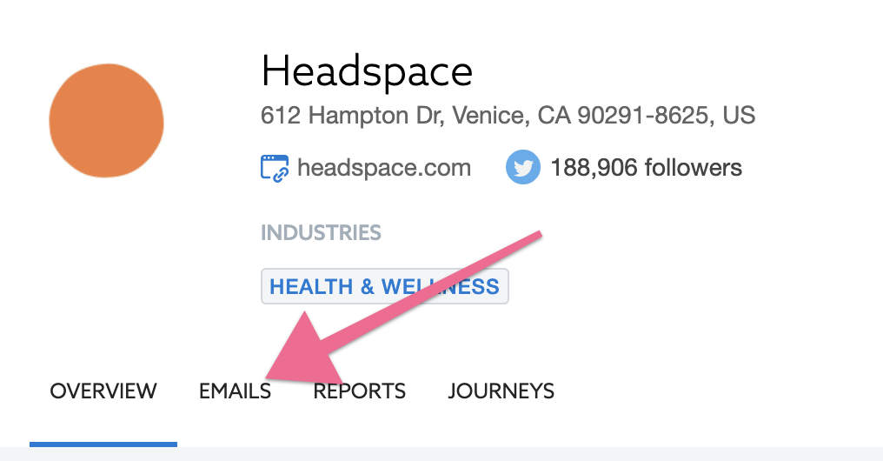
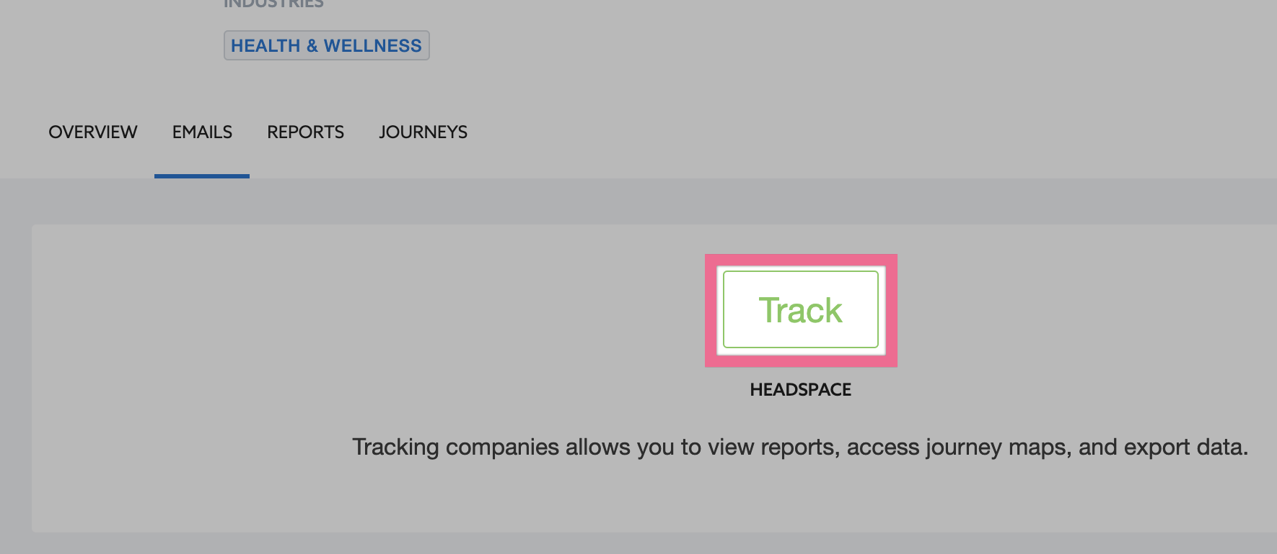
Note: Does your competitor not show up on the list? Request it to be added by clicking “Request a Brand”.
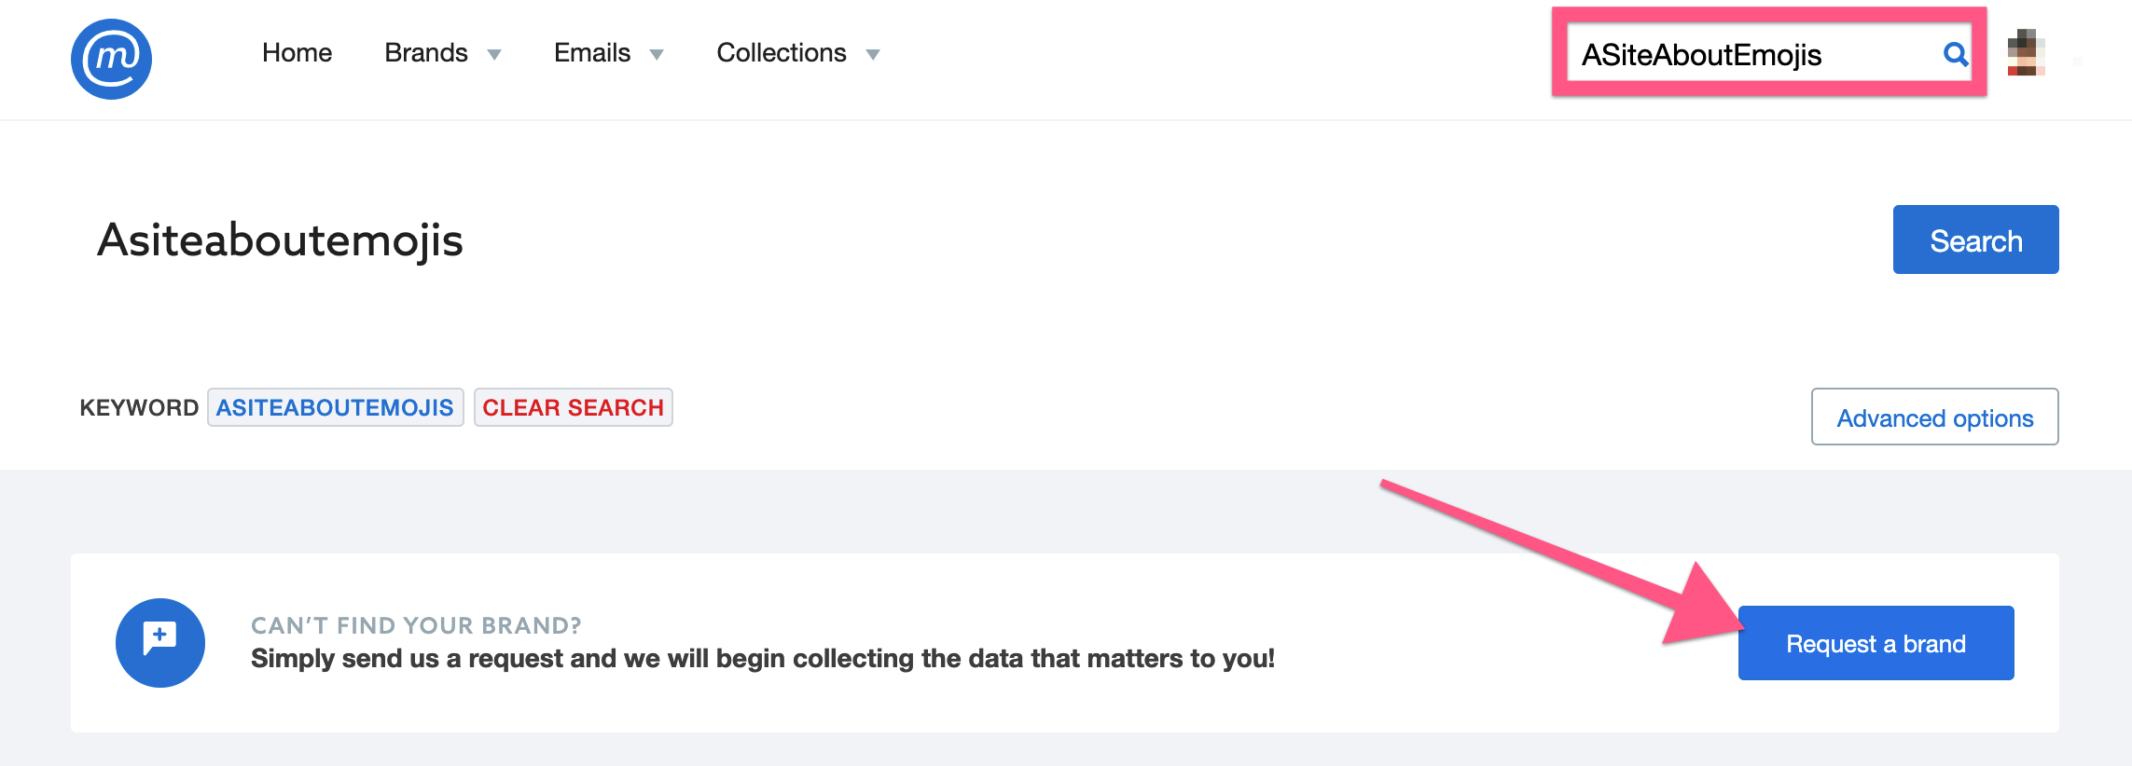

If that is the case, chances are you will not have historical data for that competitor, you can still follow this SOP but you’ll need to wait a few days/weeks until Mailcharts has enough data (enough emails sent by your competitor) to give you meaningful information.

(Option 1 - Mailcharts) Browse through your competitor’s email sequences and broadcasts

Click “Emails”:
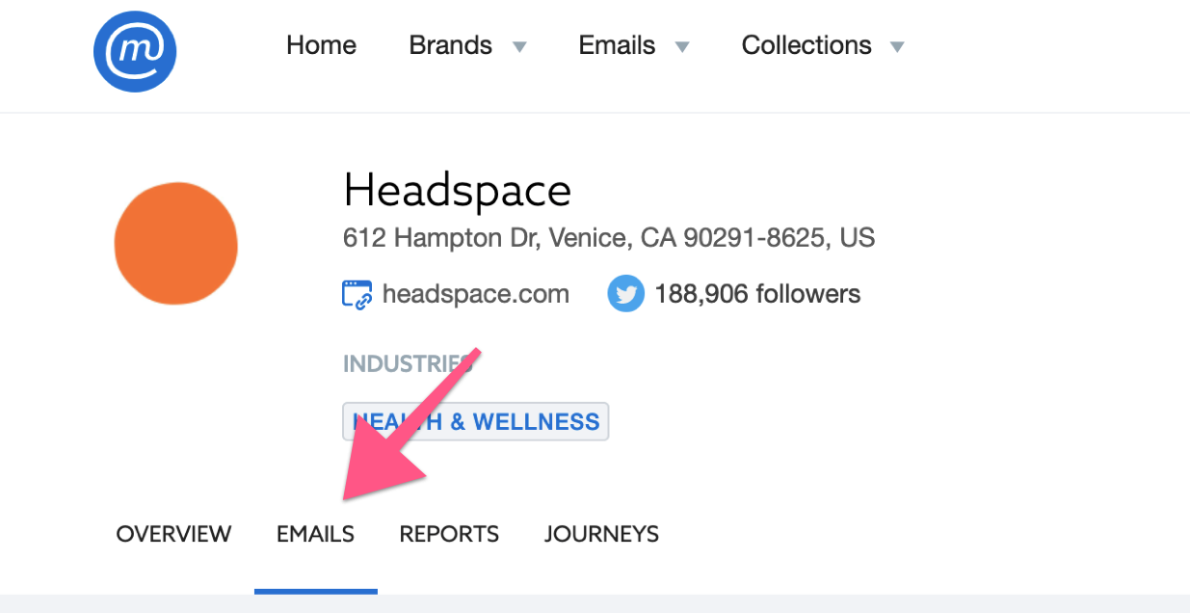

- If Mailcharts’ database was already collecting that brand’s emails, you’ll have access to all their emails for the last few weeks/months:
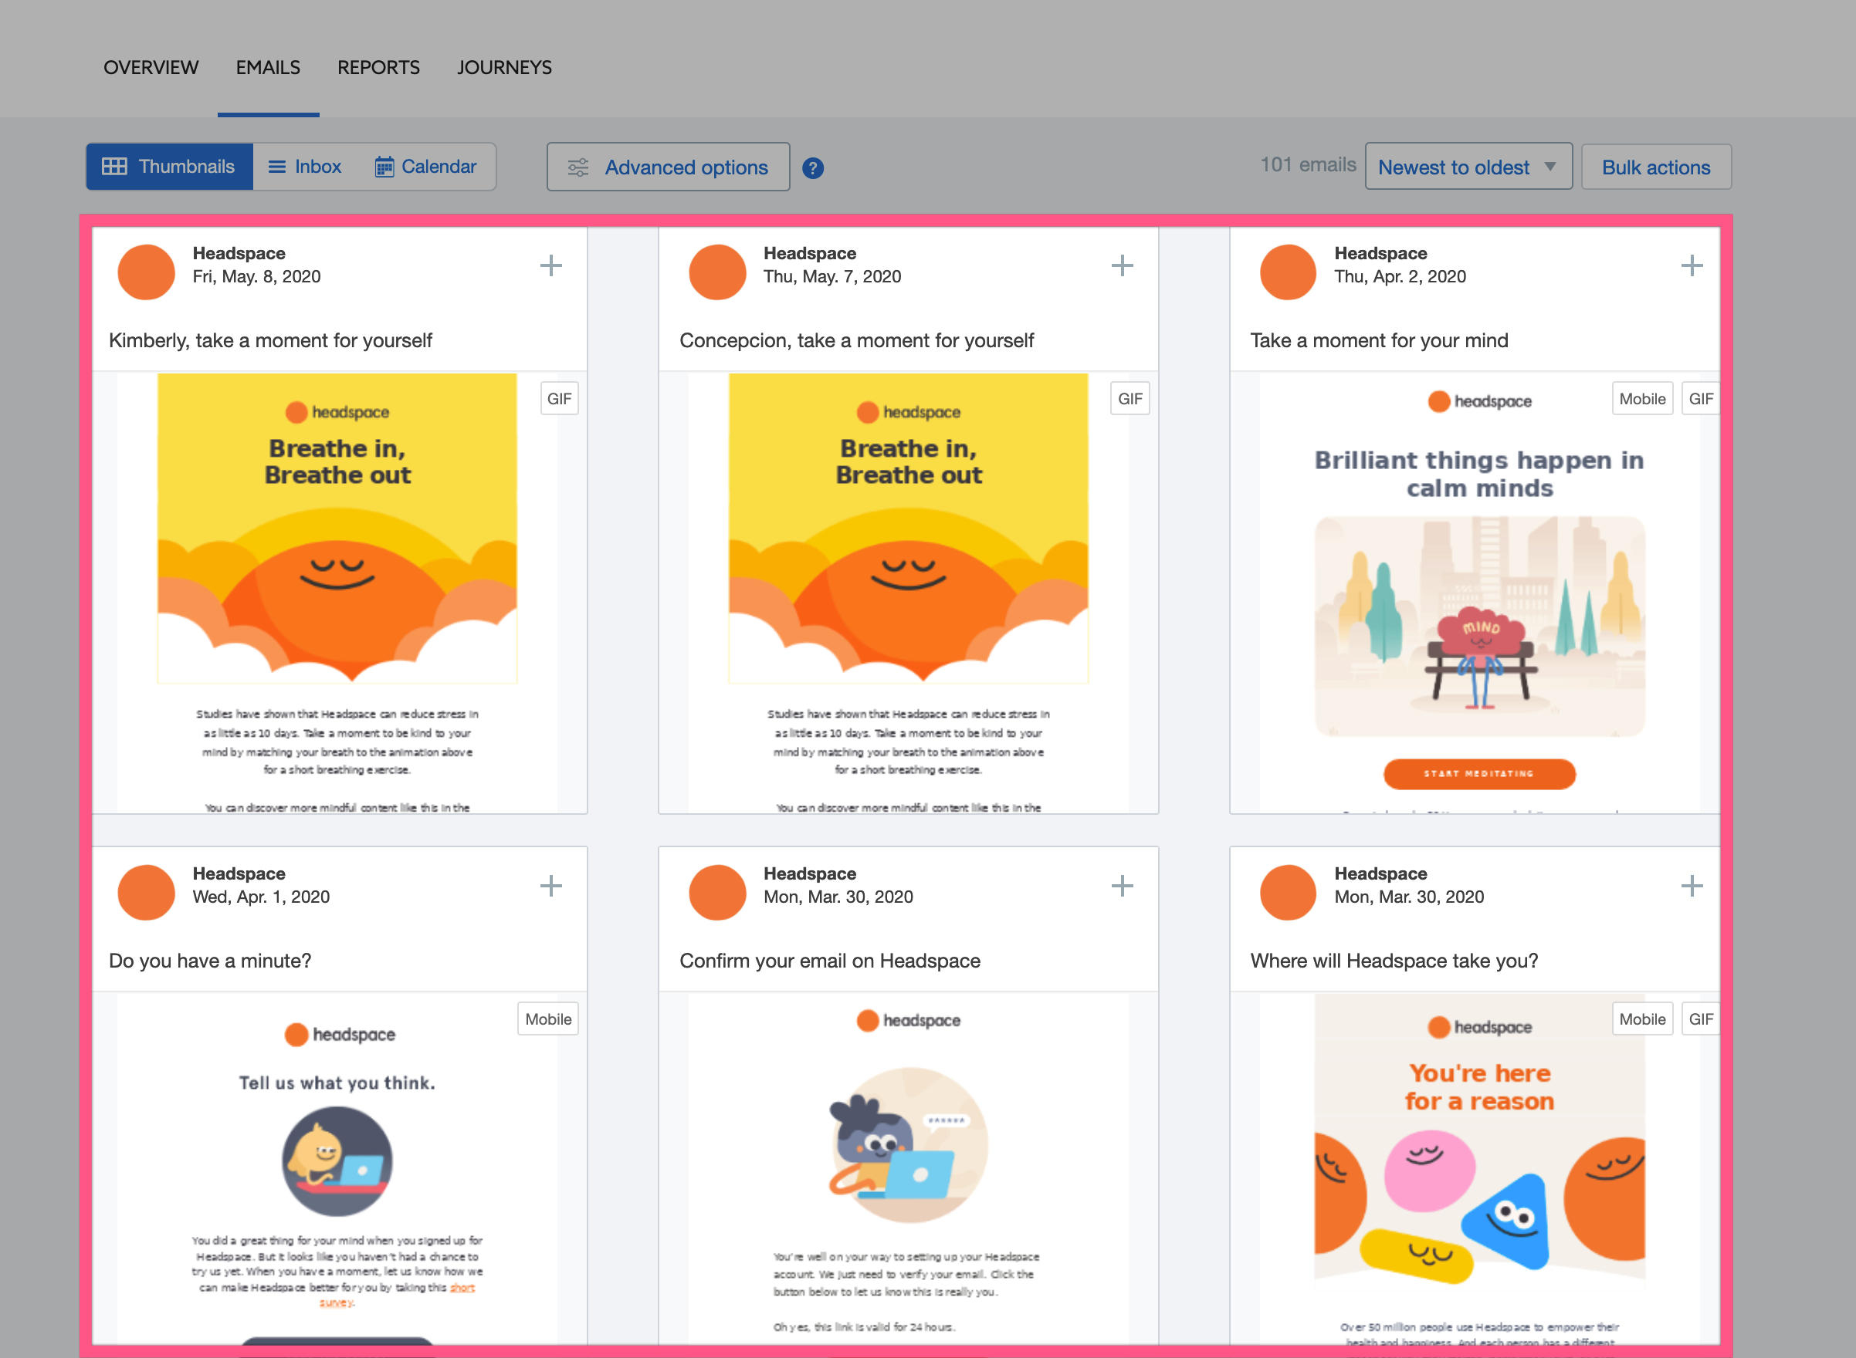
- Click ‘Advanced options’ to browse through specific categories of emails and see the individual emails:
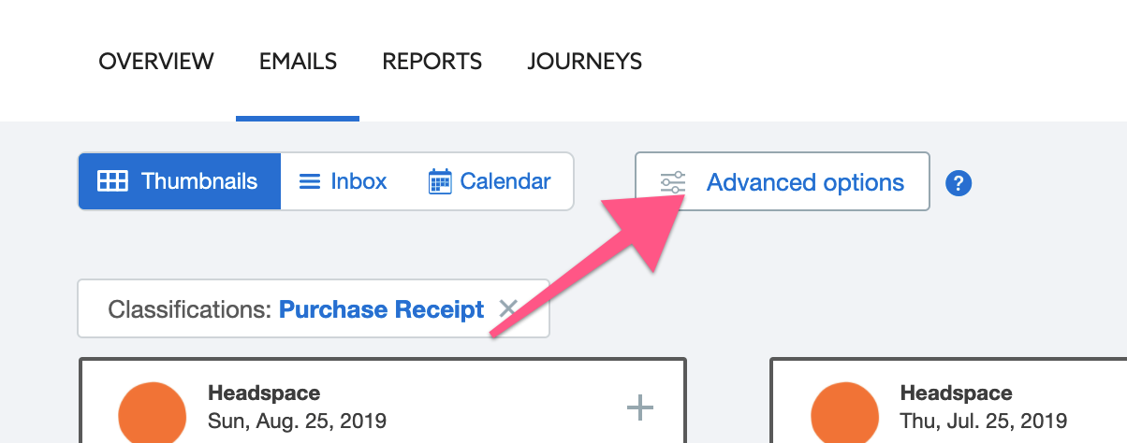

Example:
- Filtering “Purchase Receipts”:
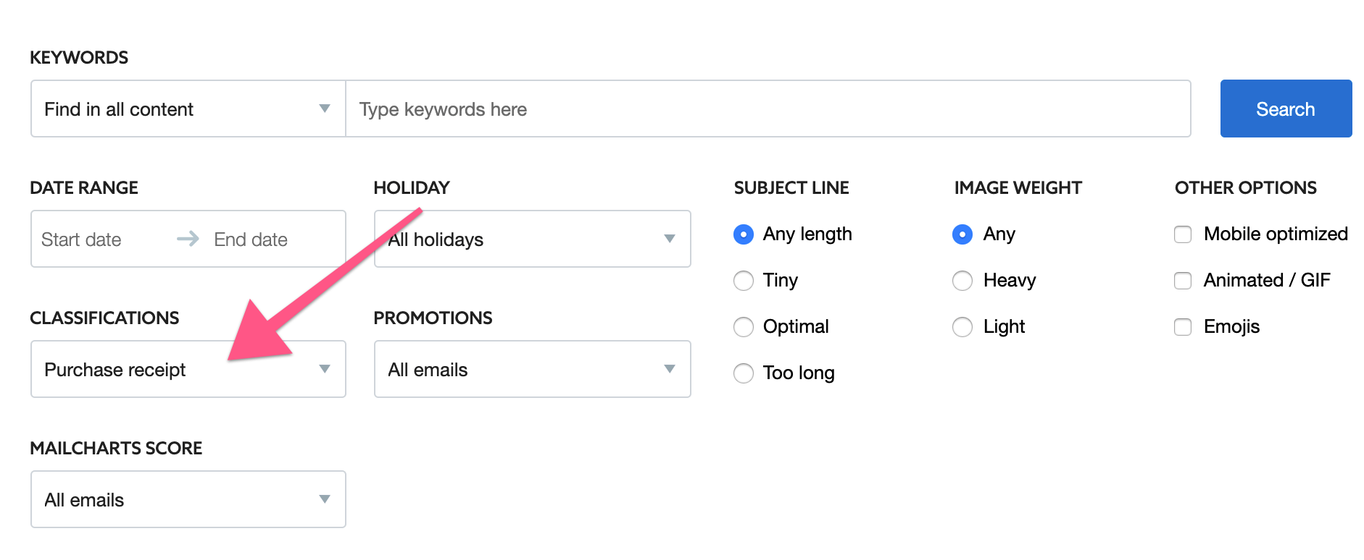

Suggestions:

Commercial emails:
- (Commercial) Welcome & Onboarding - Understand the automations that are triggered after a user signs up to your competitor.
- (Commercial) Cart & Browse Abandonment - Understand the automations that are triggered after a user adds the item to cart (or views the item product page) and then leaves the site without purchasing.
- (Commercial) Product Review - Understand the automations that are triggered after a user leaves a review for the product.
- (Commercial) Winback - Understand the automations that are triggered after a user hasn’t purchased or interacted with your competitor for a long time.
- (Commercial) Refer a friend - Understand the automations that your competitor uses to get user referrals.
- (Commercial) Promotions - Promotional emails that were sent by your competitor, could’ve been automated or broadcasts.
- (Commercial) Important holidays in your industry. (I.e. Black Friday / Cyber Monday) - Promotional emails that were sent by your competitor on specific holidays.
- (Commercial) Content - Content that your competitor sends to their list. Can be either automations or broadcasts.

Transactional emails:
- (Transactional) Purchase Receipt & Subscription Reminder - Check out the transactional emails your competitor has in place for receipts and billing reminders.
- (Transactional) Shipping & Delivery Confirmation - Check out the transactional emails your competitor has in place for shipping and delivery confirmation.
- (Transactional) Cancellation - Check out the transactional emails your competitor has in place for when an order is canceled or refunded.

(Option 1 - Mailcharts) Check your competitor’s email metrics

- Understand when your competitor sends most of their emails by clicking Reports → Select the time period you want to analyze (if you don’t know which one to pick, select “Last 365 days”)
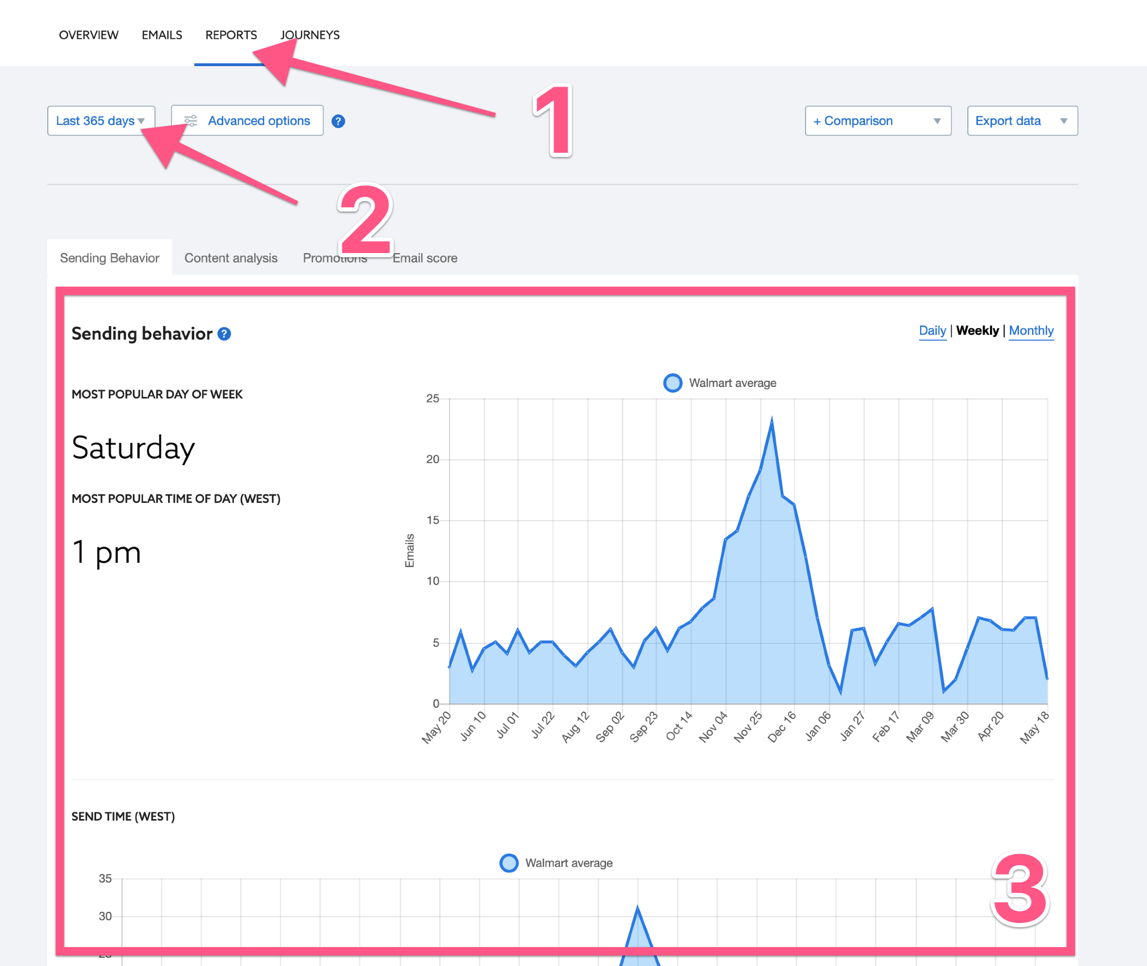

In this report you’ll learn:

- Do they mostly send emails on a specific day of the week or do they send them evenly throughout the week?

Note: To learn this, do not use the ‘Most popular day of week’ widget on the top. Instead, check the table below with the ‘Day of week analysis’:
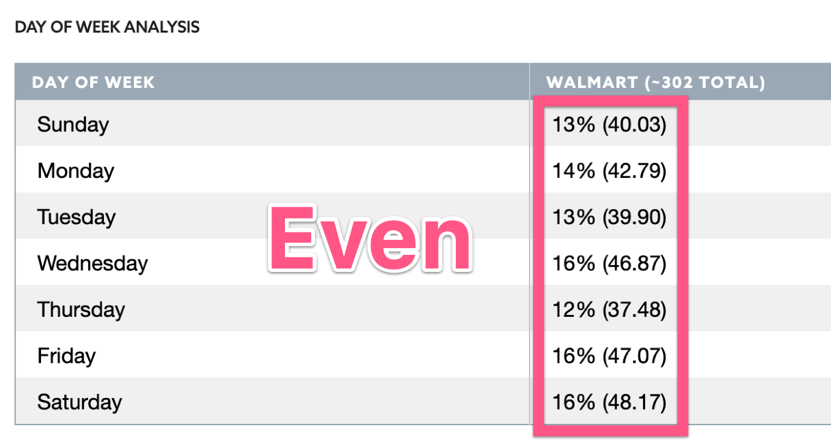

In this example, even though Saturday is the most popular day of the week for Walmart. It doesn’t seem like Walmart differentiates between days of the week when sending their emails.

- Do they send emails at a specific time of the day, or do they send it evenly / randomly throughout the day?

Note: To learn this, do not use the ‘Most popular time of day’ widget on the top. Instead, check the chart below with the ‘Send time (WEST)”:

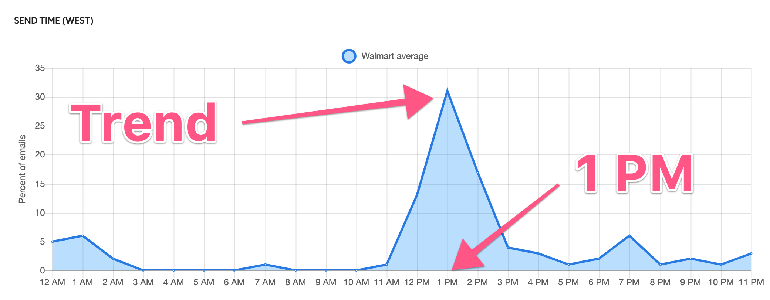

In this example, it’s clear that emails are being sent at specific times (with a few exceptions that might be due to time-sensitive automations)

- Check if your competitors are following email marketing best practices, this might give you an idea on whether email marketing is being handled professionally (therefore likely an important channel for them) or not, by clicking “Email Score” > Change the time frame to ‘Monthly’ and check their scores.
  - Email Score: The higher the % the better your competitor is doing at email marketing best practices.
  - Breakdown of the Email Score into Sub-Scores (I.e. Mobile optimized): How your competitor is doing on each best practice individually.
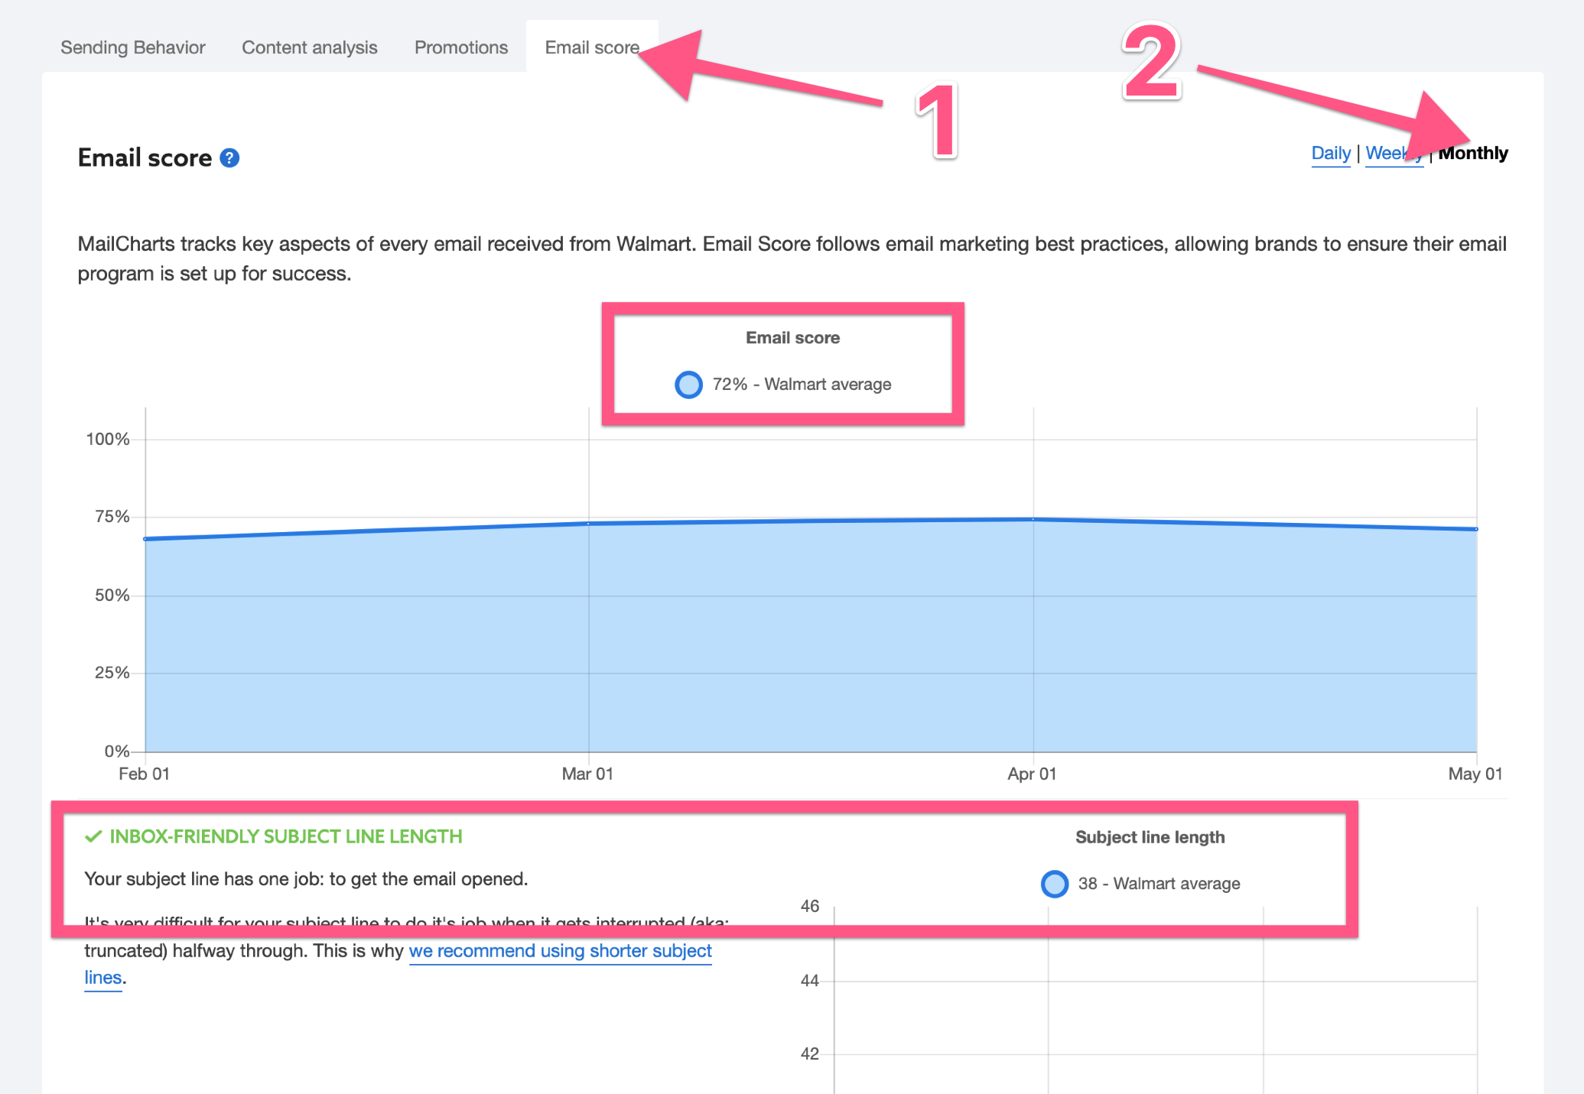

(Option 2- Simple Inbox) Setup an inbox for this purpose

- Create an inbox specifically for this purpose. (I.e. research@asiteaboutemojis.com)

Note: A simple (free) Gmail account works perfectly. If you are reverse engineering a competitor and don’t want the competitor to know this might be the best option since you can get an inconspicuous email inbox.

- To avoid having to create one inbox for each competitor, if your inbox is handled by Gmail or Google Suite, you can assign an alias for each competitor, and then use the alias feature to make sure you can segment them:
  - To do this simply add “+competitor” (no quotation marks) right before the @ symbol. By doing so, you can now use Gmail’s search (or any other email client you use) to filter out emails that were sent to that alias.
    - Example: research+headspace@asiteaboutemojis.com

Note (optional): If you also want to sign up multiple times to check if your competitor is running A/B tests or personalizations, you can also use a variant of this method by numbering your aliases. (Example: research+headspace1@asiteaboutemojis.com, research+headspace2@asiteaboutemojis.com, etc)

Likewise, if you want to differentiate between different flows (on step 3) you might want to create aliases for it. (Example: research+headspaceabandonedcart@asiteaboutemojis.com)

- Setup automated labels for incoming email
  - On the search bar of your Gmail inbox click the downwards arrow:
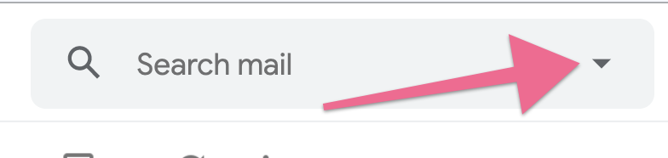
  - Type the email address (including the alias) that you are using for that competitor in the “To:” field, and click “Create Filter”:

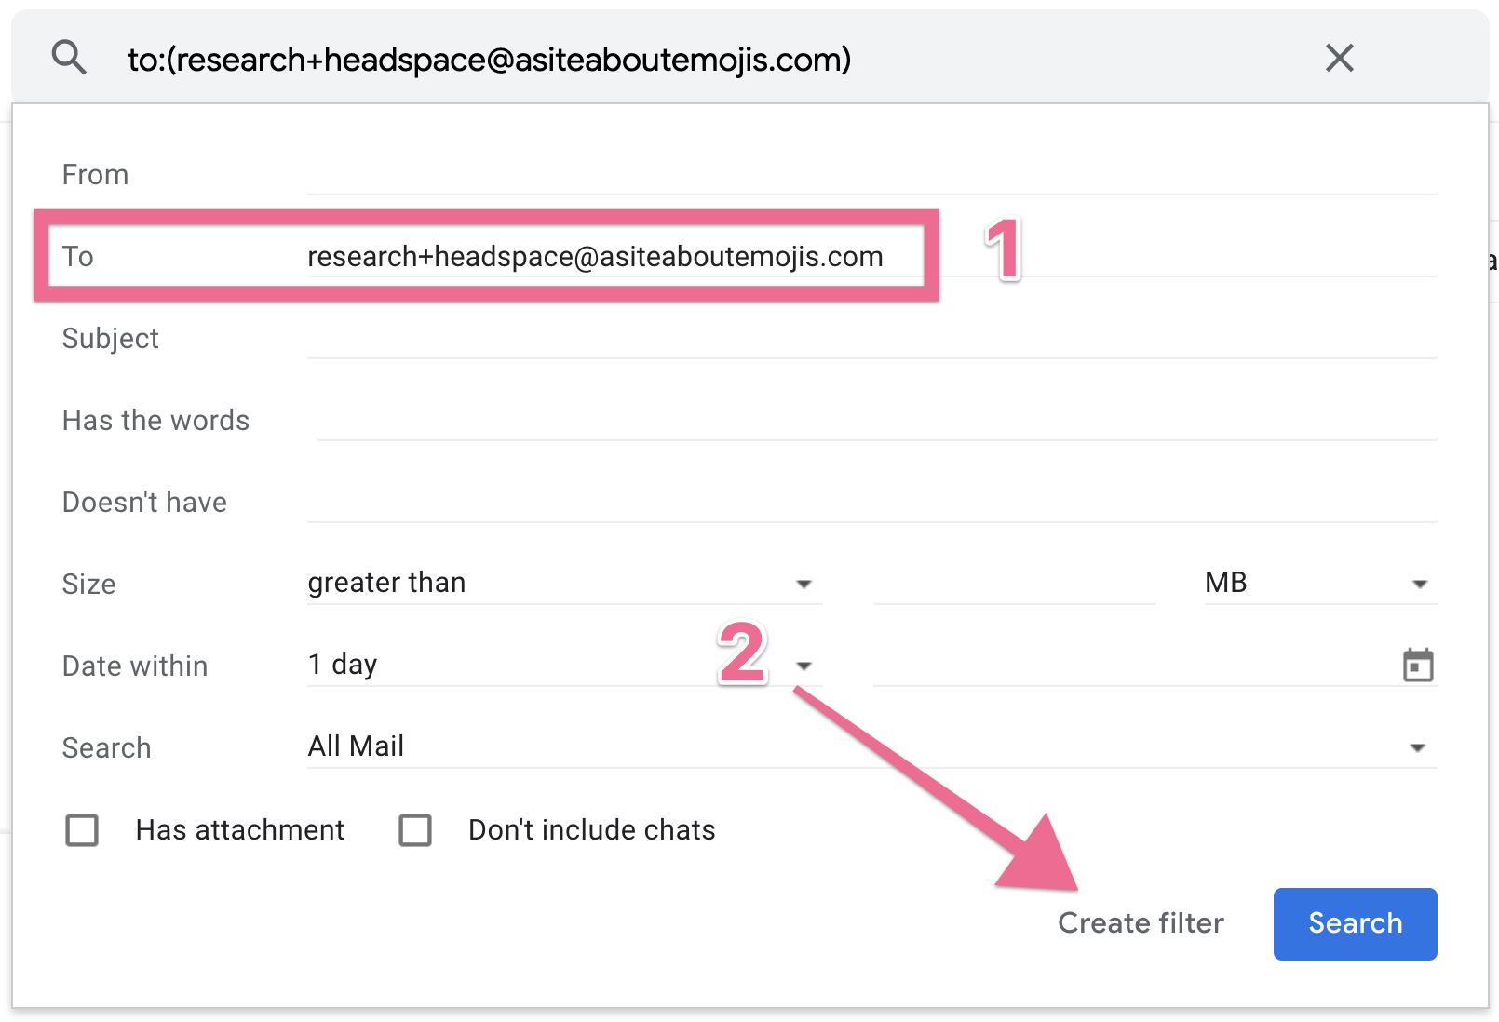

  - Click “Apply the label” → “Choose Label” → Enter your Label Name (just write your competitor’s name)


  - Click “Create filter”:


Note: Now that you have labels being added automatically to your incoming emails, as soon as that competitor starts sending you emails, you can simply click the label of the competitor you want to reverse engineer:

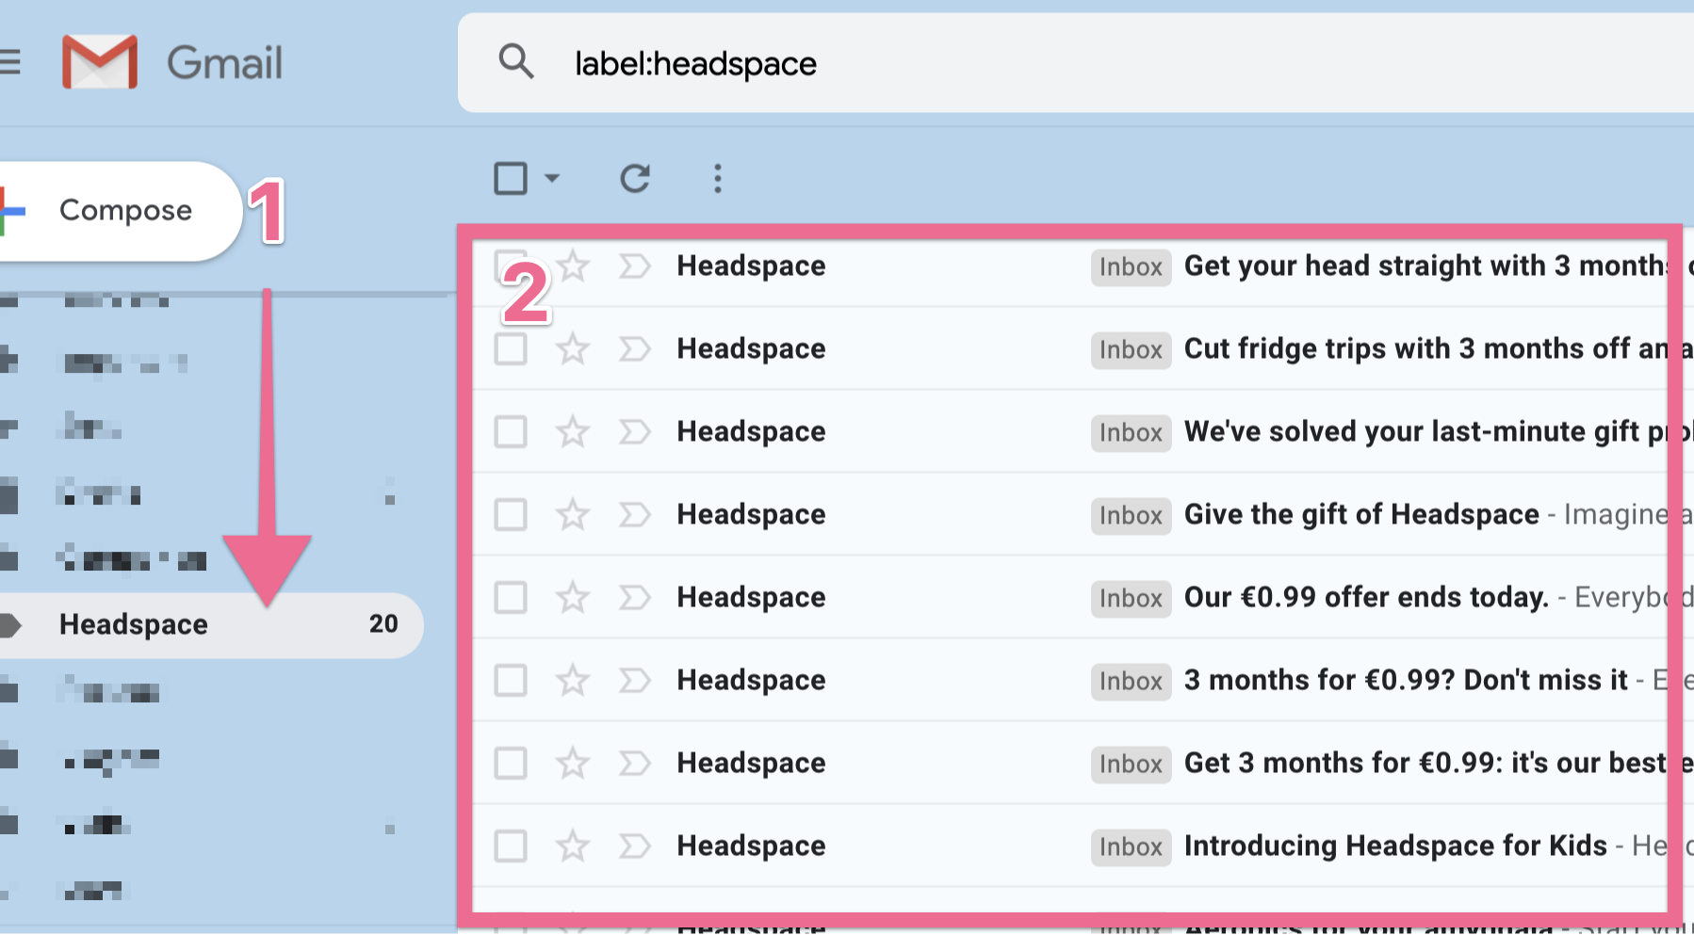

(Option 2- Simple Inbox) Sign up to your competitor’s services

- On the list below, select the flows that you believe apply to your competitor:

Commercial emails:
- (Commercial) Welcome & Onboarding - Understand the automations that kick in after a user signs up to your competitor.
- (Commercial) Cart & Browse Abandonment - Understand the automations that kick in after a user adds the item to cart (or views the item product page) and then leaves the site without purchasing.
- (Commercial) Product Review - Understand the automations that kick in after a user leaves a review for the product.
- (Commercial) Winback - Understand the automations that kick in after a user hasn’t purchased or interacted with your competitor for a long time.
- (Commercial) Refer a friend - Understand the automations that your competitor has to push customers to refer friends.
- (Commercial) Promotions - Promotional emails that were sent by your competitor, could’ve been automated or could be broadcasts.
- (Commercial) Important holidays in your industry. (I.e. Black Friday / Cyber Monday) - Promotional emails that were sent by your competitor on specific holidays, they are usually broadcasts, but in rare cases can be automations.
- (Commercial) Content - Content that your competitor sends to their list. Can be either automations or broadcasts.

Transactional emails:
- (Transactional) Purchase Receipt & Subscription Reminder - Check out the transactional emails your competitor has in place for Receipts and Billing reminders.
- (Transactional) Shipping & Delivery Confirmation - Check out the transactional emails your competitor has in place for shipping and delivery confirmation.
- (Transactional) Cancellation - Check out the transactional emails your competitor has in place for when an order is canceled or refunded.

- For each of those that you have selected perform the action-steps that should trigger the automations you are looking for.

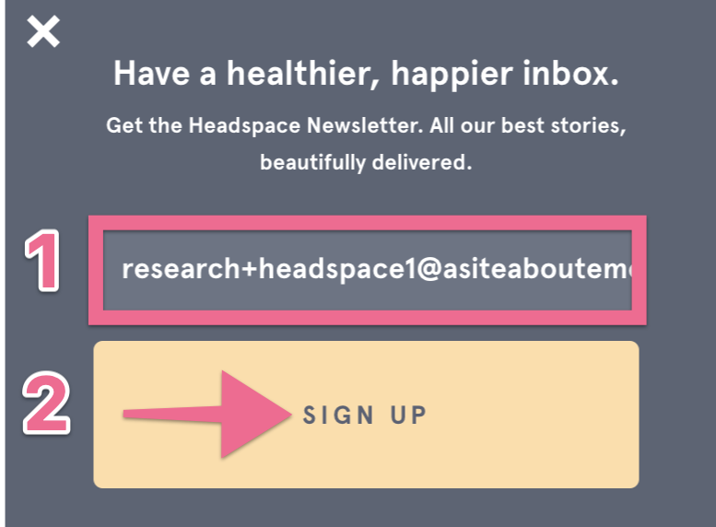

Example: (Transactional) Purchase Receipt - You’ll purchase something from your competitor. When you do so, their system should send you a receipt.

- That’s it. Depending on how long your competitor’s automations last and how much information you want to collect you might need to wait a few weeks / months until you fully have the information you’re looking for. The earliest you start the better.

Summarize your findings into an audit report

- Having been through your competitor’s emails summarize the data you collected:

- Recurring CTAs: What is it that their emails promote at each stage of the funnel?

Example:
Brand: Headspace

Leads CTA: Signup for Headspace Free
Free Users: Sign-up for a 30-day Headspace Plus Trial
Paid Users: Share the Love (Offer 30 days to a friend) // Get some Headspace (Meditate now)

- Promotions: Do they run sales or promotions frequently? What do they offer?

Example:
Brand: Headspace

Comment: Doesn’t seem to run a lot of promotions. Ran 2 promotions in the last 365 days the highest percentage was 40% OFF.

- Content: Do they send content (non-promotional) frequently? What kind of content?

Example:
Brand: Headspace

Comment: They seem to send content every couple of weeks. Typically guides or reminders of special dates related to meditation (I.e. Mental Health Awareness Month)

- Automations: Do they have automations in place? Which types?

Example:
Brand: Headspace

Comment: They seem to have automations for transactional emails, onboarding, refer a friend, pre-purchase pitch, and winback.

- Broadcasts: Do they do broadcasts frequently? Which types?

Example:
Brand: Headspace

Comment: They seem to be sending broadcasts twice a week and on special occasions (I.e. Memorial Day) these broadcasts are a 50/50 mix of promotions and content (guides).

- Split-Tests: Are they running visible split-tests on their email?

Note: In order to be able to identify split-tests, you will need to subscribe with different inboxes (recommended that you use the +modifier covered on this SOP). If you detect that the emails that were sent contain slightly different CTAs/Content, chances are that your competitor is running a split-test.

Example:
Brand: Headspace

Comment: They seem to be running an A/B test when users sign up for the free version. In one variant users are prompted to subscribe for a $1 3-month trial, on the other they are prompted for a free 30 day trial.

- Content / Promotion ratio: What’s the percentage of content or promotional emails that they are sending?

Example:
Brand: Headspace

Comment: They seem to be sending roughly 50% of content and 50% of promotional emails.

- Scheduling: Does it seem like they’re following some kind of schedule, whether that is specific weekdays or time of the day?

Example:

Brand: Headspace

Comment: They seem to be sending usually at 1PM, but they don’t seem to have a specific weekday where they usually send their emails.

- Email Marketing Best Practices: Do they typically follow email marketing best practices? (e.g. responsive emails for mobile, inbox-friendly subject length, etc)

Brand: Headspace

Comment: They’re sending subject lines with an inbox friendly subject length but the emails are not responsive and they usually are sent with heavy GIFs that make the email take longer to load.

That’s it! You now have a comprehensive overview of your competitor’s Email Marketing strategy.

